13-

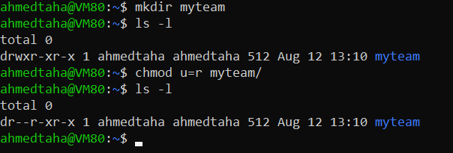

14-

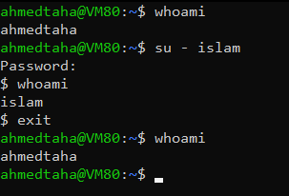

15-

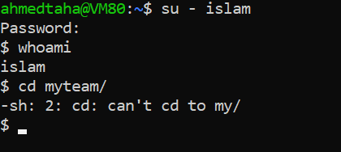

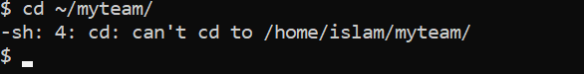

16-

1.

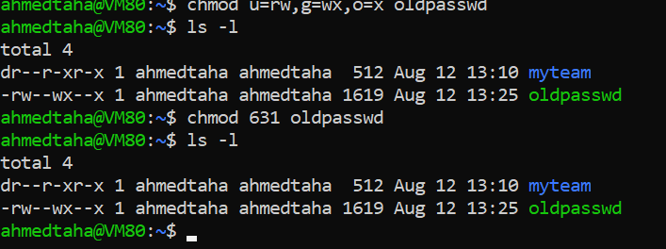

2. defult umask = 666 / file umask= 631 => 035

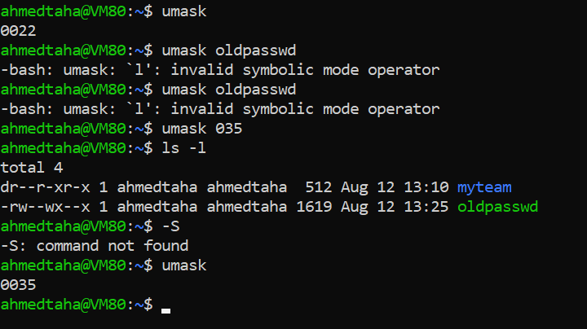

3.Defult for file => u=rw,g=rw,o=rw => 666

Defult for folder => u=rwx,g=rwx,o=rwx => 777

4-

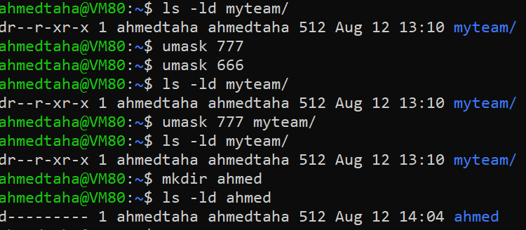

17-

|  |  |  |
| --- | --- | --- |
|  | Source | Target parent |
| Copy a directory | r-x | -wx |
| Copy a file | r-- | -wx |
| Delete a file | *---* | -wx |
| Change to a directory | --x | — |
| List directory content | r-x | — |
| View file content | r-- | — |
| Modify file content | -w- | --- |

18-

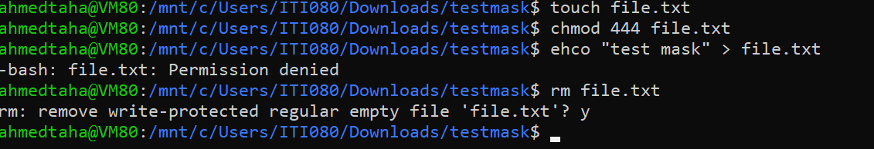

19-

1. File:x you can execute the file program
2. Folder:x you can enter dir and work with contents

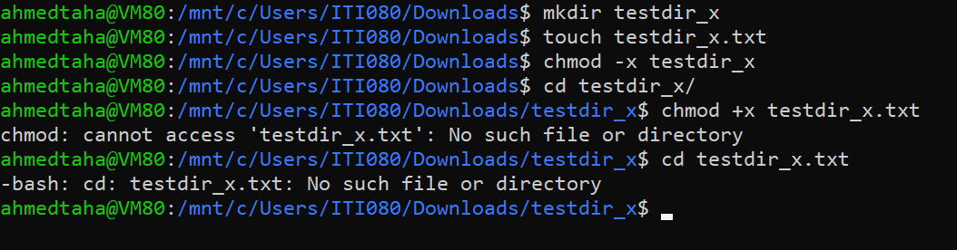

**Lab3**

1. Vi mycv (i)

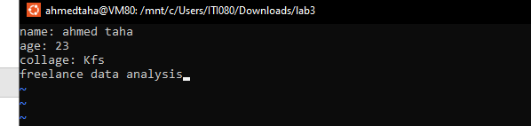

3-

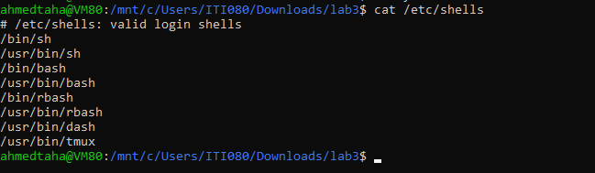

4-

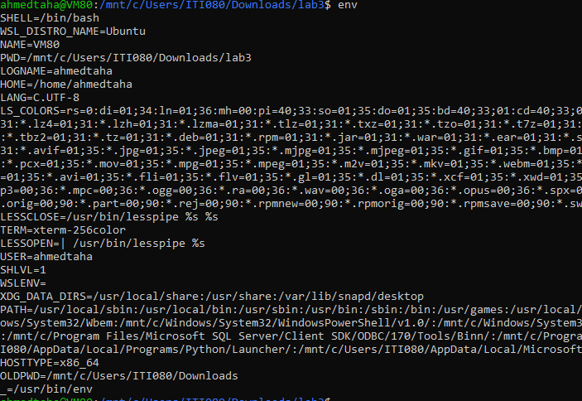

5- man bash => / => n => Variables

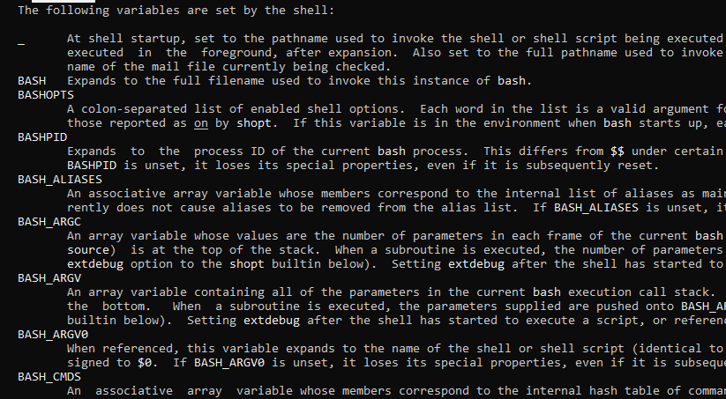

6-

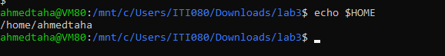

7-

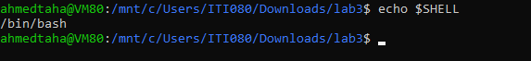

8-

sh => /etc/profile

~/.profile

--

ksh => /etc/profile

~/.profile

Bash=> /etc/profile

~/.bash_profile

~/.bash_login

~/.profile

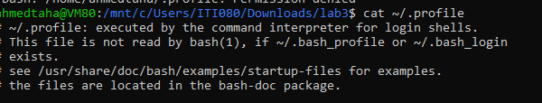

9-date => export PS1="[\u@\h \W]\$ "



10-

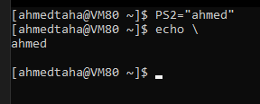

11-

